**“Development documentation* why you coded it like this - if not = FAIL”**

**Exam calendar:**

[**Digital T Level Assessment Time Tracker 25.xlsx**](https://docs.google.com/spreadsheets/d/1WHCx-cMteidwZIGeb2Q2yeRWwb_uQJJI/edit?gid=2074077842#gid=2074077842)

**Trello link:**

[**https://trello.com/b/yg1heej2/reminders-os**](https://trello.com/b/yg1heej2/reminders-os)

**Distinction exemplar 1:** [**Rigets Distinction.pdf**](https://drive.google.com/file/d/1Xsg22nSpsBjtJrthOHgMw4P2d4GjlDgl/view?usp=classroom_web&authuser=0)

**Distinction exemplar 2:**

[**https://qualifications.pearson.com/content/dam/pdf/TLevels/digital/2020/specification-and-sample-assessments/t-level-exemplification-os-digital-distinction.pdf?authuser=0**](https://qualifications.pearson.com/content/dam/pdf/TLevels/digital/2020/specification-and-sample-assessments/t-level-exemplification-os-digital-distinction.pdf?authuser=0)

**Important to leave a source, when you refer to something**

**Alarm will be useful to track the time**

[**https://vclock.com/**](https://vclock.com/)

**After signal, write everything that you didn't had time for in**

**“Notepad”**

**Ask people what can be improved**

**Task 1**

**Topic**: Analysing the problem and

designing a solution

**Evidence**: Proposal of the designed solution; A set of design documents

**Time**: 20 hours

*Contents*:

Visual/Interface designs ........................................................................................................ 2

Logo .................................................................................................................................. 2

Colour Scheme.................................................................................................................. 2

With # ............................................................................................................................ 2

Array.............................................................................................................................. 2

Object ............................................................................................................................ 2

Navigation bar ................................................................................................................... 4

Home Page ....................................................................................................................... 5

About Page ....................................................................................................................... 6

Educational Visits Page..................................................................................................... 7

Booking System ................................................................................................................ 8

Log In/ Register................................................................................................................. 9

Full solution ..................................................................................................................... 11

Data requirements .............................................................................................................. 12

ERD + Data flow.............................................................................................................. 12

ERD - Closer view........................................................................................................ 12

Data dictionary ................................................................................................................ 13

Algorithm............................................................................................................................. 15

Wireframes and the flow .............................................................................................. 15

Booking system flowchart, view – full flowchart............................................................ 15

Booking system flowchart, view – closer on main logic ................................................ 16

Booking system flowchart, view – closer on the booking a room logic.......................... 16

Booking system flowchart, view – closer on booking a ticket logic ............................... 17

A test strategy..................................................................................................................... 18

**Proposal**

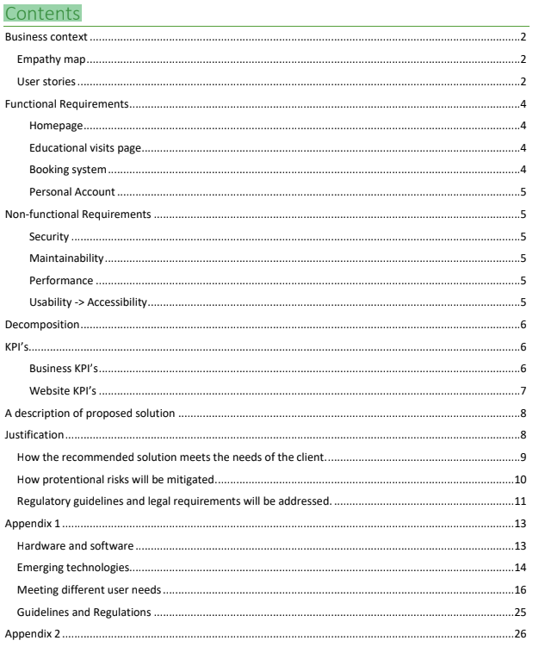

**Task 2**

**Topic**: Developing the solution

**Evidence**: Prototype; Development documents; Test Log; Code for prototype solution

**Time**: 30 hours

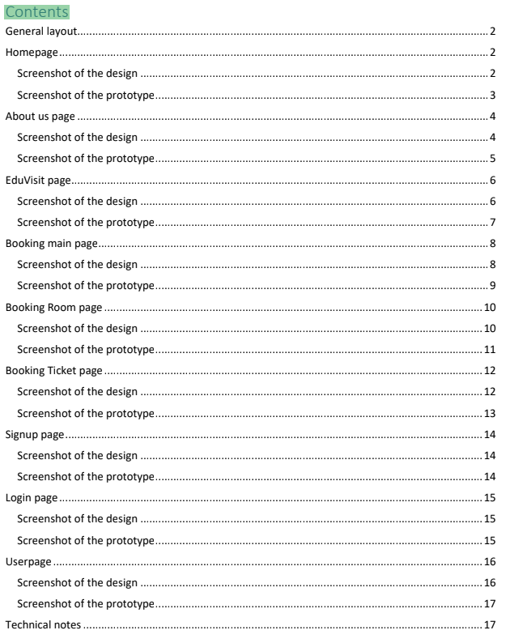

**Task 3a**

**Topic**: Gathering feedback to inform future development

**Evidence**: Plan and report on gathering feedback

**Time**: 15 hours 30 minutes

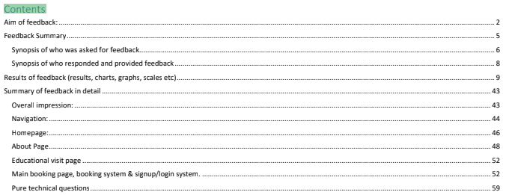

**Task 3b**

**Topic**: Evaluating feedback to inform future development

**Evidence**: Feedback evaluation report

**Time**: 2 hours

Introduction

The effectiveness of the assets and content used:

The reasoning behind selection

Home page background:

About page

The validity and reliability

Legal and ethical implications

How the digital solution meets the requirements of the solution

Functional and non-functional requirements:

Functional requirements

What the website should include:(Home page, About Page, Educational visit page, Booking system, Login/Signup/Account system)

Non-functional requirements

Security considerations

Accessibility features

KPI’s

How the prototype could be developed further